**Internet Technology Lab Test**

Create a folder named: your-group_your-last-name_C12345

Please replace your-group ​ by your group name and your-last-n​ame with your own name as it appears on

your student ID card and similarly replace C12345 with your student ID

The lab test is to consider the images of browser displays in the following pages and create the equivalent using HTML

All the details on the images, including the explanatory notes should be included, however, where indicated

please substitute your own name, student ID and group.

At the end of the lab test

1. Upload the labtest on github with **labtest2022.git** repo name
2. Repo should be private and it must be collaborate with **dadhiramp**

Finally

1. Right-mouse click on your lab test folder and Click at Send to>Compressed (zipped) Folder

2. Upload the content in orbund

Hint: for making the table border radius use inline css .

***<table style=”border-radius:10px; border:1px solid #00ff00;”>***

Good luck.

The HTML code for the following image should be saved in page1.html​.

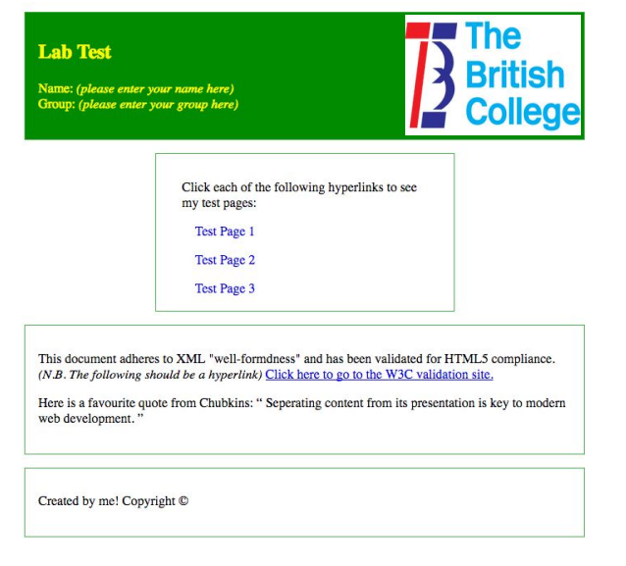

The HTML for the following image should be saved in page2.html​

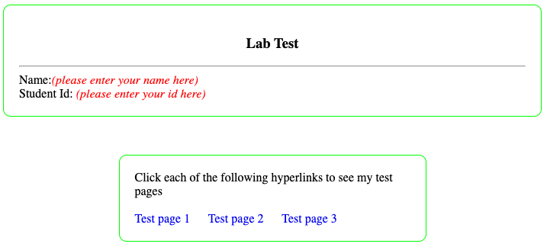

After the completion of the above work, continue with the following addition:

* + 1. Using h4 tag write “Nag Panchami”
    2. Inside the p tag paste the following text “The Nag is worshipped as the god of rain and water and is believed to bestow his devotees with wealth and prosperity with his presence in the house. It is believed that pasting the picture of the snake god also safeguards the family from snakes and scorpions, and also from fire and lightning.”
    3. Create another p tag and paste the following text “Special pujas are being observed in Nagpokhari and Taudaha in Kathmandu, Siddhapokhari in Bhaktapur and other ponds and shrines during this day.”
    4. In the above text make “Kathmandu, Siddhapokhari in Bhaktapur” bold and make the whole of second paragraph italic.
    5. Write a HTML comment with following text, “HTML is fun, when you try.”
    6. Create an anchor tag that point to <https://www.wikipedia.org/>.
    7. Create a table with columns, “S.No, Name, Address, Email” and add five data rows.
    8. Create an Unordered HTML list of online shopping sites popular in Nepal.

The HTML for the following image should be saved in page3.html

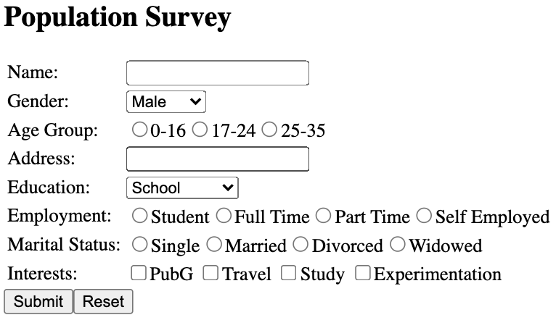

***\*Provide appropriate names to the form elements.***